  
**Process Testing**

**GROUP 12**

|  |  |  |
| --- | --- | --- |
| **STUDENT NO.** | **SURNAME** | **INTIALS** |
| 222739098 | MABATHA | J |
| 222807182 | NDLOZI | AN |
| 222822025 | DUMAKUDE | SN |
| 222850851 | NTOMBELA | LA |
| 222856523 | MAHLARE | TM |
| 222868254 | MOKOATLE | N |
| 222879825 | BANYINI | R |
| 222880084 | TAKALANI | A |
| 222884144 | DLADLA | T |
| 222885280 | DYANI | A |
| 222900620 | MAKGETHA | TG |
| 222848334 | TLALE | VB |

THEMBI M’s BAKEs & Bites

Latest trends in software testing

* **Test automation -** The increasing complexity of software being developed; automated testing is essential for faster and more efficient testing whereas the manual testing is slow and might even be redundant when adhering to the market demands.
* **Internet of things –** One of the software that gather vast troves of data on various urban facets, from traffic dynamics to environmental conditions.
* **Security Testing** - is a software testing method used on identifying and addressing the vulnerabilities, weakness, and potential risks of the system earlier in the development process. The increasing frequency of cyber-attacks, the security testing is becoming more important.
* Performance engineering – making a high-end software is something being chased by all companies and reason being that the focus on performance engineering is to optimize software performance throughout its lifecycle.

Empathy

The following problems and challenges:

* We discovered that during loadshedding the business is badly affected since it needs electricity to bake the cakes.
* Number two, since she's working alone all of the cakes have to be made by her. During a very busy week she feels under pressure but always manages to bake all the cakes with the help of her daughter.
* Number three, during summer clients always come back to complain about the cakes being damaged, when the business owner specifically instructed the customer to drive straight home to put the cake in the fridge.
* Number four, is keeping track of all the orders and where the cakes are being delivered when the customer has asked for delivery.
* Number five at first she felt as if she under-priced her cakes, especially since she was using quality ingredients. Now customers are complaining about being overcharged without understanding that when she first started the business, she had little knowledge about everything. So we can actually say that the target market went from accommodating the underprivileged to accommodating the middle class and upper class.

Define

***Loadshedding:***

Load shedding in South Africa can significantly affect small bakeries because they heavily rely on electricity to operate their equipment, such as ovens, mixers, and refrigerators. Thembi M bits and bites is no different. During load shedding, power outages can occur for hours at a time, disrupting production schedules and causing delays in baking processes. This leads to a decrease in productivity, potential loss of perishable ingredients, and ultimately, revenue loss for the bakery. Additionally, if Thembi Ms is unable to fulfil orders on time due to load shedding, they may risk losing customers and damaging their reputation.

***Long working hours:***

Due to its small scale and limited workforce comprising merely two employees, Thembi Ms business needs or functions lead to extended working hours. The exigency comes from them having to divide operational tasks among the pair, tasks including: order processing, baking procedures, and delivery arrangements.

***Hot temperatures during summer***:

Hot temperatures pose as a challenge for Thembi M’s bits and bites by affecting the consistency of ingredients, such as butter and chocolate, leading to difficulties in achieving desired textures in baked goods. High temperatures can also cause dough to rise too quickly, resulting in uneven or collapsed products. Heat can accelerate the spoilage of perishable ingredients, increasing waste and impacting profitability.

***Keeping track of orders***:

Due to the absence of a structured online ordering system at Thembi Ms, the bakery faces challenges in maintaining order accuracy and organization. Without a streamlined method, there is a heightened risk of misplacing orders, delivering incorrect items to customers, and encountering difficulties in tracking order dates. Moreover, their manual order-taking process proves to be time-consuming and labour consuming further adding to operational inefficiency.

Ideation

* **Digital Calendar and Scheduling tool**: an online tool to help baking and delivery schedules.
* **Database System**: to help Thembi’s bakery to keep record of the orders in a computer system.
* Well, we opted out for an Online Ordering system which will be a website that will allow customers to place orders digitally.
* This will help the bakery by reducing order-taking errors associated with manual entries.
* It will also help reduce the time it takes it takes to place orders and it will also help the bakery to work more efficiently and in a well-organized and productive manner. The website will also have an in-built GIS system that will help track down the order and delivery dates with their respective addresses.

 ​

**test scenarios**

* Check if user can create a new account.
* Verify if user can login to their account.
* Verify if user can be redirected to the home page after login.
* Check if products are displayed with their product description on the website.
* Check that user can add items to the cart and can go to checkout.
* Verify that customer can modify, and that system can display total cost.
* Verify that customer receive an order confirmation.
* Verify that user can effectively use the payment methods securely so.
* Check that customer can track the status of their order.
* Check that payment process is done correctly.
* Verify that user can provide feedback on the service rendered to them.
* Verify that websites displays reviews provided by customers.

Test Cases

1. Test Case 1: User Account Creation

2. Test Case 2: User Login

3. Test Case 3: Redirect to Home Page

4. Test Case 4: Display Product Description

5. Test Case 5: Add Items to Cart and Checkout

6. Test Case 6: Modify Cart and Display Total Cost

7. Test Case 7: Order Confirmation

8. Test Case 8: Payment Method Security

9. Test Case 9: Order Tracking

10. Test Case 10: Provide Feedback and Display Reviews

* Each test case addresses a specific functionality or requirement, contributing to the overall quality assurance process.



Flow Chart

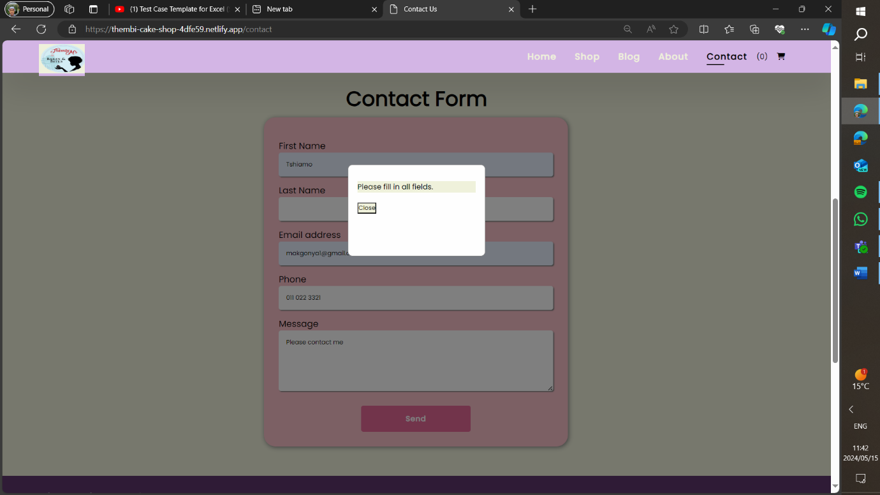

[Website](https://thembi-cake-shop-4dfe59.netlify.app/)









